***A Mini Project-2 Report submitted***

***in partial fulfillment of the requirements for the award of the degree of***

### BACHELOR OF TECHNOLOGY

***In***

### COMPUTER SCIENCE & ENGINEERING

***By***

1. M. Sita Varshini - 18B01A05A3 3. M. Haritha – 18B01A05A2

2. K. Vasudha Lakshmi- 18B01A0593 4. S. Divya Sri – 18B01A05B8

5. K.V. Mani Madhuri – 19B05A0511

***Under the esteemed guidance of***

**Mr. K. Ravi Teja (M. tech - PhD)**

***Asst.* Professor**



# DEPARTMENT OF COMPUTER SCIENCE & ENGINEERING SHRI VISHNU ENGINEERING COLLEGE FOR WOMEN(A)

##### (Approved by AICTE, Accredited by NBA & NAAC, Affiliated to JNTUKakinada)

**BHIMAVARAM – 534 202**

**2020 – 2021**

**SHRI VISHNU ENGINEERING COLLEGE FOR WOMEN(A)**

**(Approved by AICTE, Accredited by NBA & NAAC, Affiliated to JNTU Kakinada)**

**BHIMAVARAM – 534 202**

**DEPARTMENT OF COMPUTER SCIENCE & ENGINEERING**



**CERTIFICATE**

This is to certify that the Mini Project-1 entitled “**CRAFTS E-COMMERCE WEBSITE**”, is being submitted by **M. Sita Varshini, K. Vasudha Lakshmi, M. Haritha, S. Divya Sri, K.V. Mani Madhuri** bearing the **Regd. No.18B01A05A3,18B01A0593, 18B01A05A2, 18B01A05B8,19B0A0511** in partial fulfillment of the requirements for the award of the degree of “**Bachelor of Technology** in **Computer Science & Engineering**” is a record of bonafide work carried out by them under my guidance and supervision during the academic year 2020–2021 and it has been found worthy of acceptance according to the requirements of the university.

##### Internal Guide Head of the Department

**ACKNOWLEDGMENTS**

The satisfaction that accompanies the successful completion of any task would be incomplete without mention of the people who made it possible and those who constant encouragement and guidance has been a source of inspiration throughout the course of this project. We take this opportunity to express our gratitude to all those who helped us in this project.

We wish to place our deep sense of gratitude to **Sri. K. V. Vishnu Raju, Chairman of SVES** for his constant support on each and every progressive work of us.

Our deep sense of gratitude and sincere thanks to **Dr. G. Srinivasa Rao, principal of SVECW** for being a source of an inspirational constant encouragement

Our deep sense of gratitude and sincere thanks to **Dr. P. Srinavasa Raju, vice- principal of SVECW** for being a source of an inspirational constant encouragement

We deeply indebted and sincere thanks to **Dr.P. Kiran Sree, Head of the department** for his valuable advices in completing this project successfully

Our deep sense of gratitude and sincere thanks to **Mr. K.Ravi Teja, Assistant Professor** for his unflinching devotion and valuable suggestion throughout this project.

**Project Associates**

##### 1.M. Sita Varshini - 18B01A05A3

##### 2.K. Vasudha Lakshmi - 18B01A0593

##### 3.M. Haritha - 18B01A05A0

##### 4.S. Divya Sri - 18B01A05B8

##### 5.K.V. Mani Madhuri - 19B05A0511

**CONTENTS**

|  |  |  |
| --- | --- | --- |
| **S.NO** | **TOPIC** | **PAGE NO** |
| 1 | **Introduction** | 06 |
| 2 | **System Analysis**   * 1. Existing System   2. Proposed System   3. Feasibility Study | 07  07  07 |
| 3 | **System Requirements Specification**   * 1. Software Requirements   2. Hardware Requirements | 09  10 |
| 4 | **System Design**   * 1. Introduction   2. UML Diagrams | 10  11 |
| 5 | **System Implementation**   * 1. Introduction   2. Project Modules   3. Screens | 20  21  22 |
| 6 | **System Testing**   * 1. Introduction   2. Testing Methods   3. Test Cases | 27  28  28 |
| 7 | **Conclusion** | 29 |
| 8 | **Bibliography** | 30 |
| 9 | **Appendix**   * 1. Introduction to Html   2. Django   3. Python | 31  32  32 |

|  |  |  |
| --- | --- | --- |
| **S.NO** | **UML DIAGRAMS** | **PAGE NO** |
| 1 | Use Case Diagram | 13 |
| 2 | Class Diagram | 15 |
| 3 | Sequence Diagram | 17 |
| 4 | Activity Diagram | 19 |
|  |  |  |
|  |  |  |
|  |  |  |

1. **INTRODUCTION**

* **ARTIFACT:** An artifact is an object made by a human being. Artifacts include art, tools, and clothing made by people of any time and place. The term can also be used to refer to the remains of an object, such as a shard of broken pottery or glassware
* These days people are interested in collecting artifacts, but the available of these artifacts confined to some areas only
* This Project aims to make all the different artifacts available at one place in our website.
* Our website is user friendly as it helps the customers to find the artifacts that the customers are looking for.
* Our Web site is used for reducing the difficulty for people to buy the artifacts.
* It is safe for customer since it avoids the customer to travel to buy the artifacts.
* As it is an online website it is available for all the customers from any where at any time.
* Earlier a customer had to pre-plan his shopping trip even if he wanted to buy a specific thing. It would mean rearranging his schedule and going to out to purchase artifacts. One of the main benefits of ecommerce is that it saves time.
* The characteristics, its usefulness, and specifications are listed in a detailed manner. Even the colours of some of the products are mentioned so that you can make a choice according to personal preference.
* No geographical limitations, a physical store is located in a particular place and in most cases the people who live nearby come and visit it. One of the benefits of e-commerce stores is that it is not bound by geographical boundaries.
* A customer can access the portal from anywhere in the world with the help of an internet connection and a device to operate it. The platform is available 24/7 to all its customers in any part of the world and he can also cancel orders.

1. **SYSTEM ANALYSIS**

### Existing System

* + - Existing System consists of features like ordering the product and adding the product to the cart.
    - If the customer confirms to buy the product, then he proceeds to delivery option.
    - **Disadvantage:**

It does not the bother about the customer requirement if the product is not

Available i.e., the customer cannot get the customized products which they require.

### Proposed System

“Crafts E-Commerce” website allows the customer to get the customized products

It is the main advantage in this website. Here the customer can register and login into the website. he can order the products any time and he can add products to his wishlist. This website also allows the customer to add/delete items from the cart. The Customer orders will be visible to the seller so that he will accept that order and sends Order details to delivery boy. The customer can order the product to any location he wants. The customer can pay the amount after the product is reached i.e., at the time of delivery. This website offers fast delivery, so that the customer need not wait f or a longer time.

* Along with features of the existing system we have implemented a new feature which is on-demand product delivery by using message option from customer side.
* The customer can request directly to the seller via a message, regarding the product that he wants, If the product is not available currently. He can add basic description of the product that he want and the seller receives the message from the customer and response accordingly

**Adavantage:**

Customer has a chance to communicate with the shopkeeper for the customized product that he require if it is unavailable in the website.

### Feasibility Study

Generally the feasibility study is used for determining the resource cost, benefits and whether the proposed system is feasible with respect to the organization. The proposed system feasibility could be as follows. There are six types of feasibility which are equally important are:

* + - Technical feasibility
    - Economic feasibility
    - Behavioural feasibility

#### Technical Feasibility

#### Technical feasibility deals with the existing technology, software and hardware requirements for the proposed system. Thus the project is consider technically feasible further development using Django. The work for the project can be done with current equipment, existing software technology and available personnel. Hence the proposed system is technically feasible.

#### Economic Feasibility

Since the required hardware and software for developing the system is already available in the organization/system, it does not cost must developing the proposed system.

#### Behavioural Feasibility

This project has been implemented by phyton and it satisfies all conditions and norms of the organization and the users. This proposed system “Hand Gesture Detection” Application has much Behavioal feasibility because users are provided with a better facility

## SYSTEM REQUIREMENTS SPECIFICATION

### Software Requirements

HTML (Hyper Text Markup Language)

CSS (Cascading Style Sheet)

Django

sqlite3

**Editor:** Sublime text3

**Language:**  Python

### Hardware Requirements

RAM – 4 GB

Processor – Intel core i5 Hard Disk – 1TB

## SYSTEM DESIGN

### 4.1 Introduction

**System design** is the process of designing the elements of a system such as the architecture, modules and components, the different interfaces of those components and the data that goes through that system.

**System Analysis** is the process that decomposes a system into its component pieces for the purpose of defining how well those components interact to accomplish the set requirements. The purpose of the System Design process is to provide sufficient detailed data and information about the system and its system elements to enable the implementation consistent with architectural entities as defined in models and views of the system architecture.

The purpose of the design phase is to plan a solution of the problem specified by the requirement document. This phase is the first step in moving from problem domain to the solution domain. The design of a system is perhaps the most critical f actor affecting the quality of the software, and has a major impact on the later phases, particularly testing and maintenance. The output of this phase is the design document. This document is similar to a blue print or plan for the solution, and is used later during implementation, testing and maintenance.

The design activity is often divided into two separate phase-system design and detailed design. System design, which is sometimes also called top-level design, aims to identify the modules that should be in the system, the specifications of these modules, and how they interact with each other to produce the desired results. At the end of system design all the major data structures, file formats, output formats, as well as the major modules in the system and their specifications are decided.

While including CSS file to the HTML we could not able to insert the CSS. After searching we found that we had not add path in settings.py file. Could not display images retrieved from the table in the website. After correcting the syntax we got the images. We faced some problem while inserting data into the database. The data is being read but could not store in the table later we found that it is due to naming conventions.

### UML Diagrams

UML Diagrams is a rich visualizing model for representing the system architecture and design. These diagrams help us to know the f low of the system.

Some of them are:

* + - Use case diagram
    - Sequence diagram
    - Collaboration diagram
    - State chart diagram

### USE CASE DIAGRAMS

A Use Case Diagram in the Unified Modelling Language (UML) is a type of behavioural diagram defined by and created from a Use-case analysis. Its purpose is to present a graphical overview of the functionality provided by a system in terms of actors, their goals (represented as use cases), and any dependencies between those use cases.

The main purpose of a use case diagram is to show what system functions are performed for which actor. Roles of the actors in the system can be depicted. Interaction among actors is not shown on the use case diagram. If this interaction is essential to a coherent description of the desired behavior, perhaps the system or use case boundaries should be re-examined. Alternatively, interaction among actors can be part of the assumptions used in the use case.

##### Use cases:

A use case describes a sequence of actions that provide something of measurable value to an actor and is drawn as a horizontal ellipse.

##### Actors:

An actor is a person, organization, or external system that plays a role in one or more interactions with the system.

##### System boundary boxes:

A rectangle is drawn around the use cases, called the system boundary box, to indicate the scope of system. Anything within the box represents functionality that is in scope and anything outside the box is not.

Four relationships among use cases are used often in practice.

##### Include:

In one form of interaction, a given use case may include another. "Include is a Directed Relationship between two use cases, implying that the behaviour of the included use case is inserted into the behaviour of the including use case.

The f irst use case often depends on the outcome of the included use case. This is use f ul f or extracting truly common behaviours from multiple use cases into a single description. The notation is a dashed arrow from the including to the included use case, with the label "«include»". There are no parameters or return values. To specify the location in a f low of events in which the base use case includes the behaviour of another, you simply write include followed by the name of use case you want to include, as in the following f low f or track order.

##### Extend:

In another form of interaction, a given use case (the extension) may extend another. This relationship indicates that the behaviour of the extension use case may be inserted in the extended use case under some conditions. The notation is a dashed arrow from the extension to the extended use case, with the label "«extend»". Modellers use the «extend» relationship to indicate use cases that are "optional" to the base use case.

##### Generalization:

In the third form of relationship among use cases, a generalization/specialization relationship exists. A given use case may have common behaviours, requirements, constraints, and assumptions with a more general use case. In this case, describe them once, and deal with it in the same way, describing any differences in the specialized cases. The notation is a solid line ending in a hollow triangle drawn from the specialized to the more general use case (following the standard generalization notation

##### Associations:

Associations between actors and use cases are indicated in use case diagrams by solid lines. An association exists whenever an actor is involved with an interaction described by a use case. Associations are modelled as lines connecting use cases and actors to one another, with an optional arrowhead on one end of the line. The arrowhead is often used to indicating the direction of the initial invocation of the relationship or to indicate the primary actor within the use case.

##### Identified Use Cases

The “user model view” encompasses a problem and solution from the preservative of those individuals whose problem the solution addresses. The view presents the goals and objectives of the problem owners and their requirements of the solution. This view is composed of “use case diagrams”. These diagrams describe the functionality provided by a system to external integrators. These diagrams contain actors, use cases, and their relationships

## USE CASE DIAGRAM

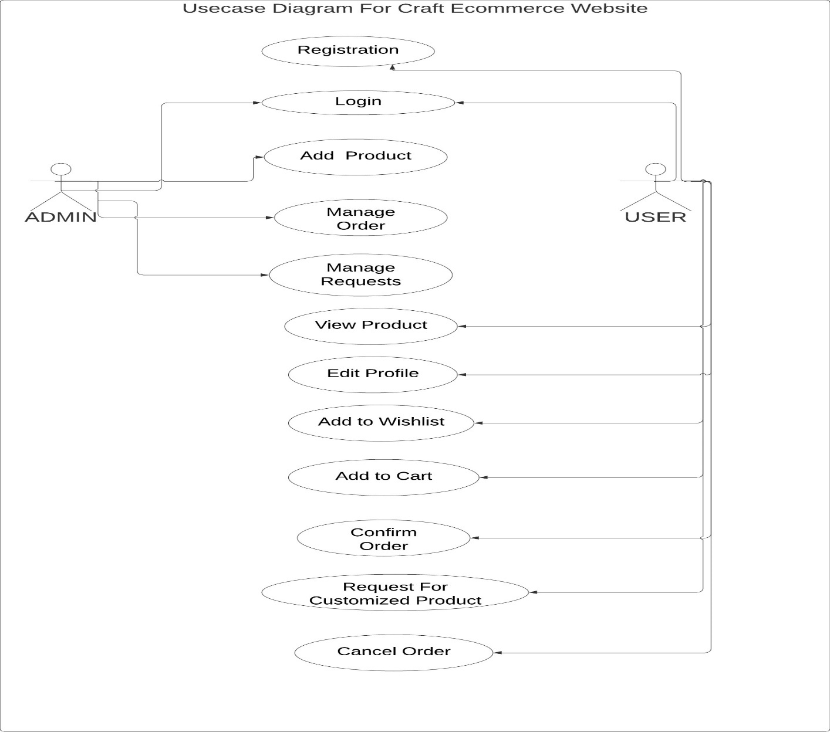

1.Actor: Admin, User

2.Usecases: Login, Add product, Manage order, manage requests, view product, editprofile, add to wishlist, add to cart, confirm order, Request for customized product, cancel order.

**CLASS DIAGRAM:**

In software engineering, a class diagram in the Unified Modeling Language is **a type of static structure diagram** that describes the structure of a system by showing the system's classes, their attributes, operations and the relationships among objects.

Purpose of Class Diagrams.

* Shows static structure of classifiers in a system
* Diagram provides a basic notation for other structure diagrams prescribed by UML
* Helpful for developers and other team members too
* Business Analysts can use class diagrams to model systems from a business A UML class diagram is made up of:
* A set of classes and
* A set of relationships between classes

**CLASS NAMES:** Customer, Product, order, wishlist, Cart, Request

**ATTRIBUTES:**

For Customer: id, first Name, last name, Phone number, MailId, password

Product: id, product name, image, price, Category, description, quantity

Order: Order Id, customer, product, cart, address, country, state, city, zipcode, total-amount

Wishlist: Id, customer, product

Cart: product, customer, quantity, total

Request: customer, product type, description

**OPERATIONS:**

For Customer: login(), register(), requestProduct(), makeOrder(), logout(), addTo Cart(), addToWishlist(), productDetail(), editProfile()

For Admin: manageOrder(), manageRequestProduct(), uploadProduct()

## CLASS DIAGRAM

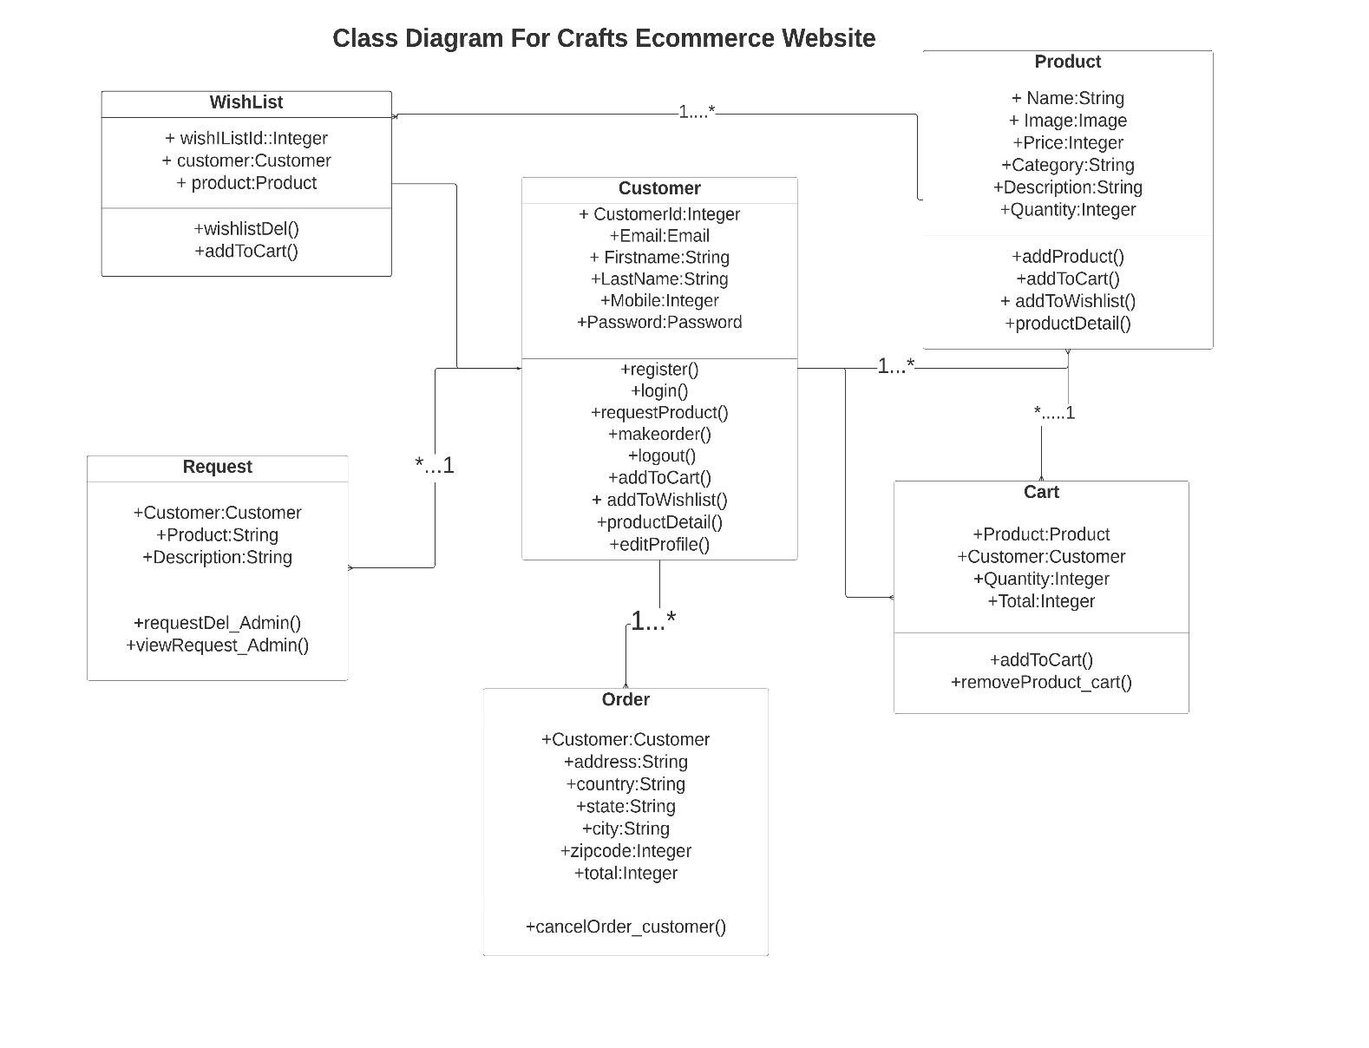

**SEQUENCE DIAGRAMS:**

Sequence Diagrams are interaction diagrams that detail how operations are carried out. They capture the interaction between objects in the context of a collaboration.

Sequence Diagram captures:

* the interaction that takes place in a collaboration that either realizes a use case or an operation.
* high-level interactions between user of the system and the system, between the system and other systems, or between subsystems.

Purpose of Sequence Diagram

* Model the high-level interaction between active objects in a system.
* Model the interaction between object instances within a collaboration that realizes a use case.
* Model the interaction between objects within a collaboration that realizes an operation.
* Either model generic interactions or specific instances of a interaction.

**OBJECTS**: admin, customer, website.

The Customer can Register, Login into the website he can view the products and he can also make request for customized products. he can add them to the cart. The customer can make the order. The customer can also cancel the order. Admin manages the website.

## SEQUENCE DIAGRAM

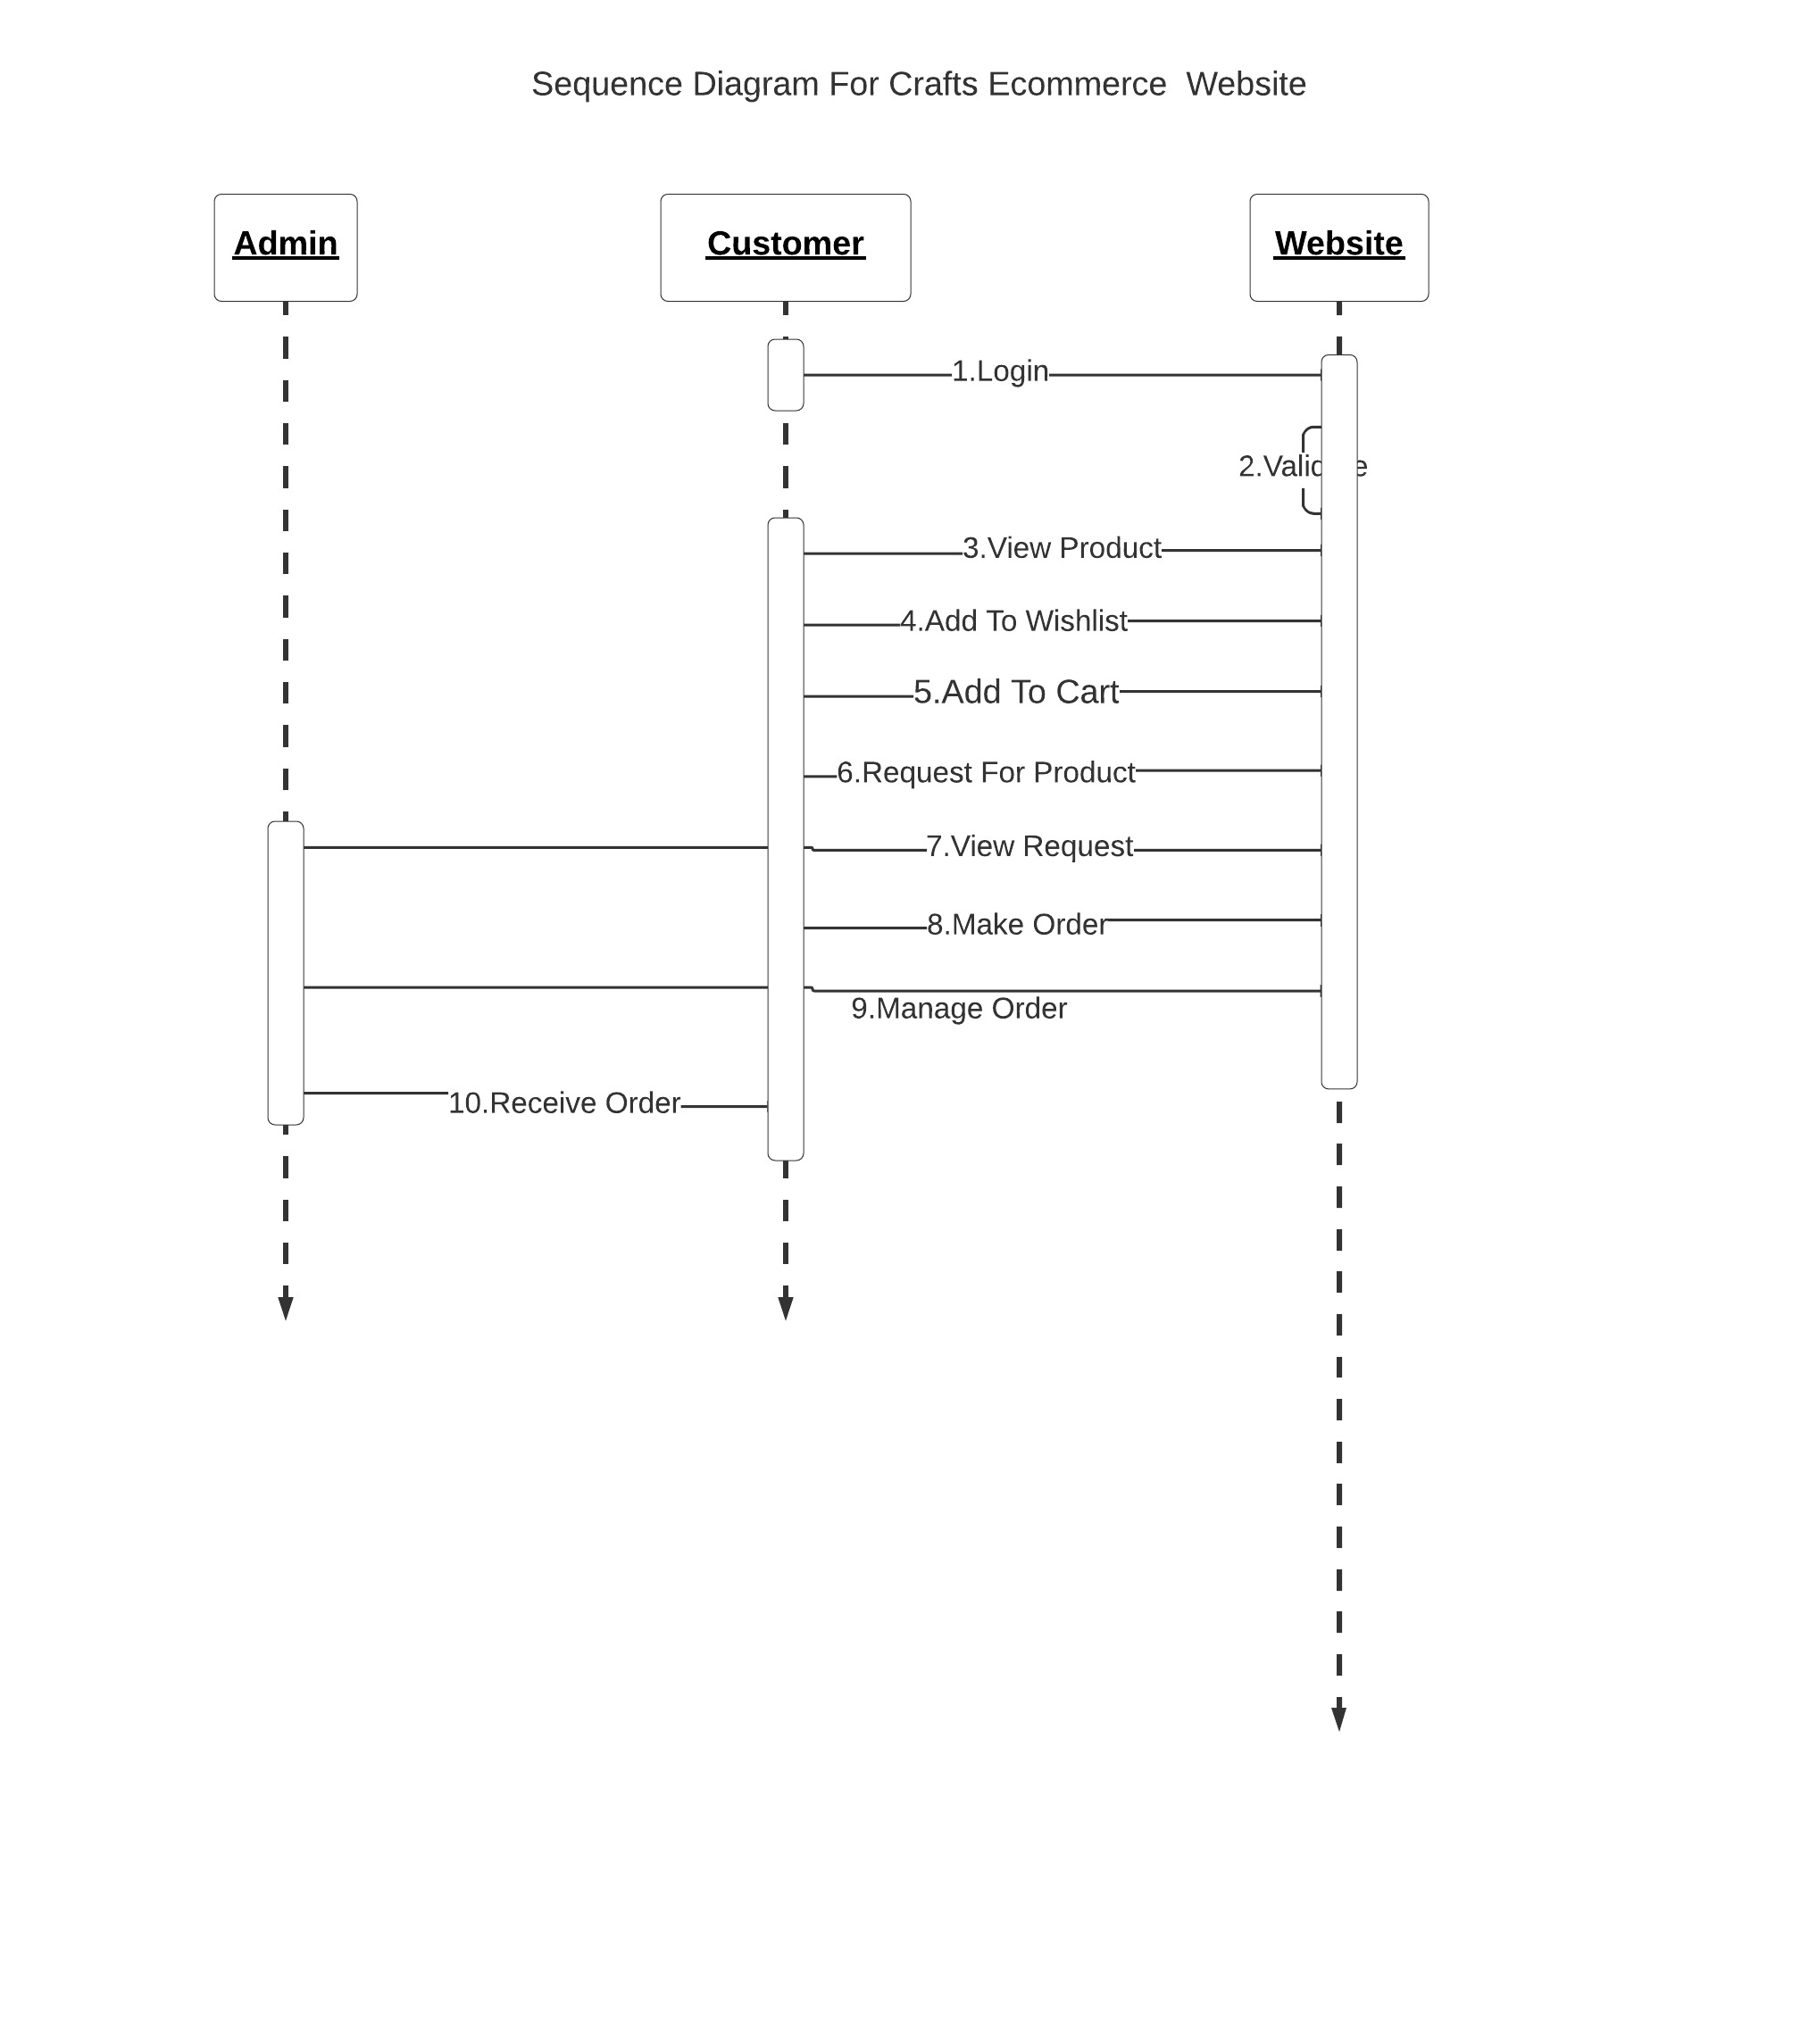

**ACTIVITY DIAGRAMS:**

Activity diagram is another important behavioral diagram in uml diagram to describe dynamic aspects of the system. Activity diagram is essentially an advanced version of f low chart that modeling the f low from one activity to another activity.

**Purpose of Activity Diagrams**

* Draw the activity f low of a system.
* Describe the sequence from one activity to another.
* Describe the parallel, branched and concurrent flow of the system.

Initially the customer enters his credentials in the website. If the credentials are invalid he is asked to enter valid credentials otherwise the website will redirect to homepage. If the customer likes any product then he will add the Product item to cart and wishlist. If the product is not available in the website he can request to the admin regarding the product. The Product items which are added to the cart will be displayed with the price in the cart and the customers can order it.

## ACTIVITY DIAGRAM

## 

1. **SYSTEM IMPLEMENTATION**

### Introduction

### In our Project admin will maintain the complete website, Admin will upload product detail into the website and he also manage orders and product requests. Customer will register into the website and then he will enter his credentials in login page, if they are valid he will be redirect to the homepage. In homepage the customer can view product details and he can select product with respect to category provided and then if he likes the Product he will add to wishlist, if the required product is not available in website the customer can request to seller for the customized product via request product page.

### if he wants to buy the product then he can add to the cart and the customer can also see the product description and details. In add to cart page the product, product quantity and its price is displayed here the customer can increase the product quantity and the total cost of the products will be displayed and then customer will place the order.

### 5.2 Project Modules

#### Register/Login:

Initialy the customer register and then logins. If the customer did not have an account, he/she will register in order to create an account to use the website. The customer is asked to enter the details like firstname, lastname, phone number, email id, to create an account. All these details will be stored in the database.

#### Wishlist:

#### In this module, The customer can add his favorite product to wishlist and he can also remove products from wishlist.

#### Add to cart:

In this module, If the customer wants to buy the product then he will add the product to the cart. Total cost of the products will be displayed.

#### Requesting for Product:

Customer can make a request to seller for the customized product through message option if that product is not available in the website.

#### Cancel order:

#### If he do not want to buy the product then he will cancel the order.

#### Add Item (Admin):

#### The admin will upload product details like image, quantity, price and description of the Product into the website

#### 1.Login&Register:

#### 

**Homepage:**

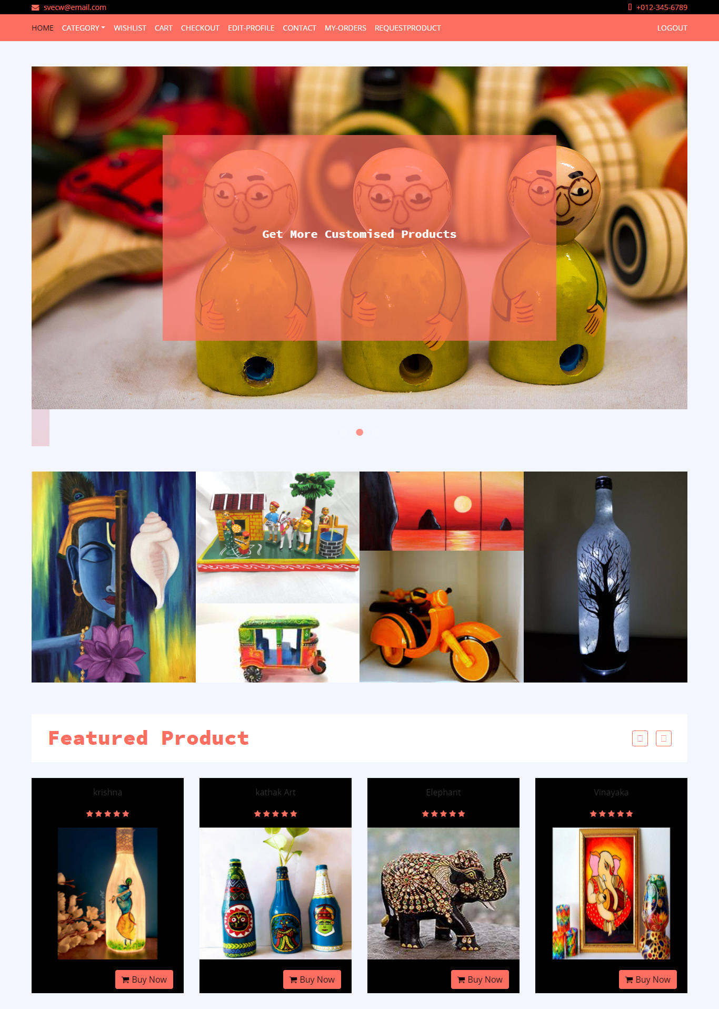

**2.Products:**

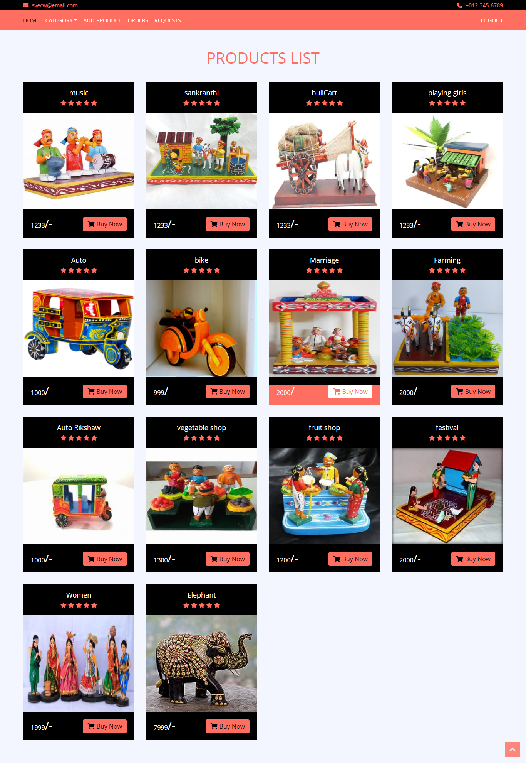

**3.Wishlist:**

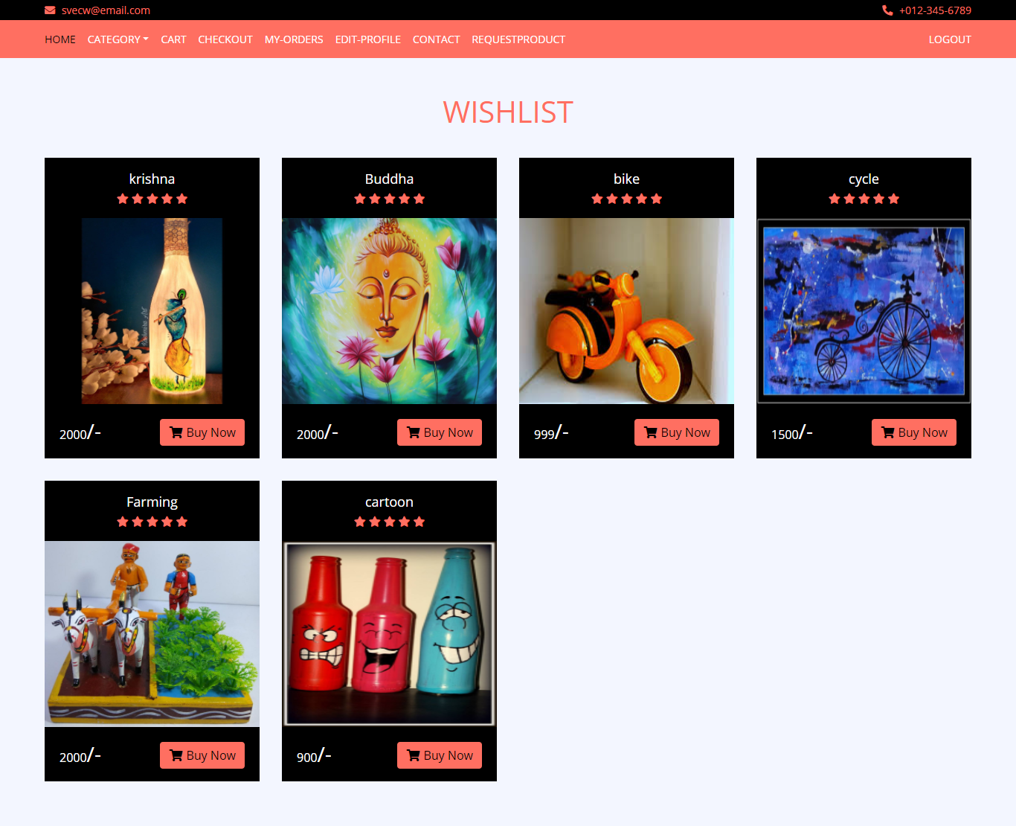

**3. Add to cart:**

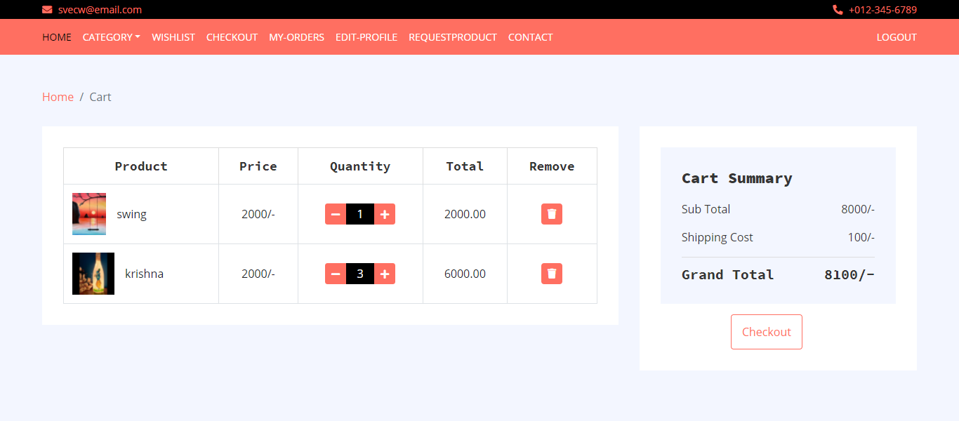

**4.Requesting For Product:**

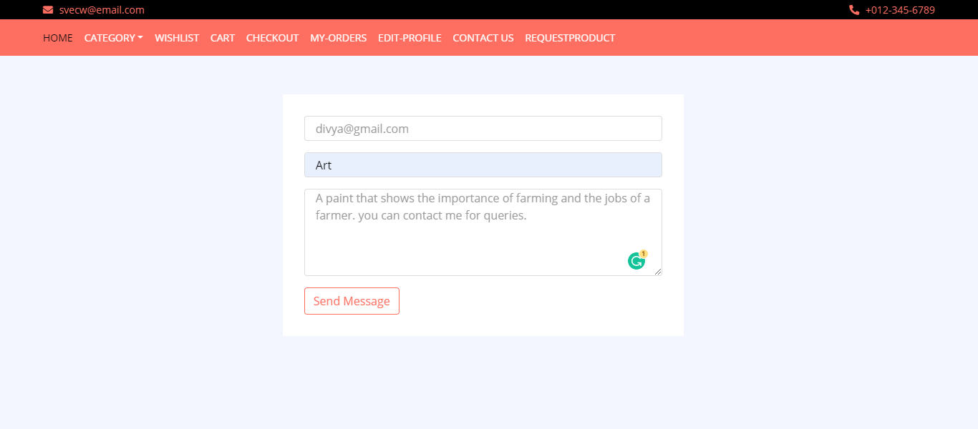

**5.Add Product (Admin):**

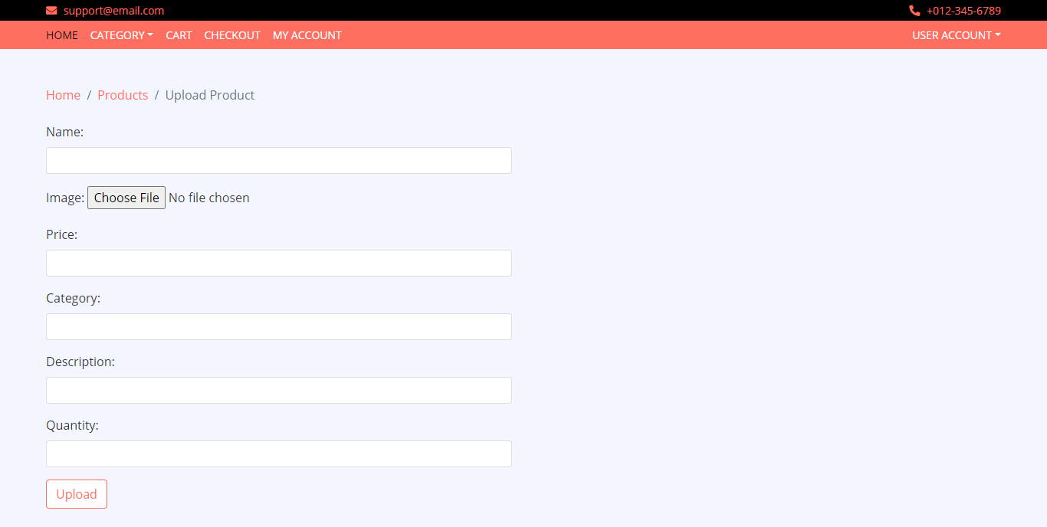

1. **SYSTEM TESTING**
   1. **Introduction:**

Software Testing is an important element of the software quality assurance and represents the ultimate review of specification, design and coding. The increasing feasibility of software as a system and the cost associated with the software f ailures are mot ivated forces for III planned through testing.

##### TESTING OBJECTIVES

These are several rules that can save as testing objectives:

* + - Testing is a process of executing program with the intent of f inding an error.
    - A good test case is one that has a high probability of f inding an undiscovered error.

##### Test Levels

The purpose of testing is to discover errors. Testing is the process of trying to discover every conceivable fault or darkness in a work product. It provides a way to check the functionality of components, subassemblies, assemblies and/or a finished product. Software system meets its requirements and user expectations and does not fail in an unacceptable manner. There are various types of test. Each test type addresses a specific testing requirement.

### Testing Methods

##### Unit Testing

Unit testing involves the design of test cases that validate that the internal program logic is functioning properly, and that program inputs produce valid outputs. All decision branches and internal code f low should be validated. It is the testing of individual sof tware units of the application.

##### Integration Testing

Integration tests are designed to test integrated software components to determine if they run as one program. Testing is event driven and is more concerned with the basic outcome of screens or f ields.

**FUNCTIONALITY TESTING:**

Functional tests provide systematic demonstrations that functions tested are available as specified by the business and technical requirements, system documentati on, and user manuals. Organization and preparation of functional tests is focused on requirements, key functions, or special test cases.

##### System Testing

System testing ensures that the entire integrated software system meets requirements. It tests a configuration to ensure known and predictable results. An example of system testing is the configuration oriented system integration test.

##### White Box Test

White Box Testing is a testing in which in which the software tester has knowledge of the inner workings, structure and language of the software, or at least its purpose. It is purpose. It is used to test areas that cannot be reached from a black box level.

##### Black Box Test

Black Box Testing is testing the software without any knowledge of the inner workings, structure or language of the module being tested. Black box tests, as most other kinds of tests, must be written from a definitive source document, such as specification or requirements document, such as specification or requirements document.

##### Unit Testing

Unit testing is usually conducted as part of a combined code and unit test phase of the software lifecycle, although it is not uncommon for coding and unit testing to be conducted as two distinct phases.

##### Integration Testing

Software integration testing is the incremental integration testing of two or more integrated software components on a single platform to produce failures caused by interface defects.

##### Acceptance Testing

User Acceptance Testing is a critical phase of any project and requires significant participation by the end user.

## CONCLUSION

Artifacts are made with lot of efforts and their availability is also confined to some places. It will be difficult for a person to go to different places to buy the product. So, Inorder to make these artifacts available at every place we came up with a website where all kinds of artifacts will be available at your fingertips. Any person can easily login to our website and find the crafts according to categories that he want and can order them or he can also add the products to his wishlist at his interest. If the customer requires any product that is unavailable in the website he can add a message for the admin requesting the customized product so that the admin tries to add that requested product

## Bibliography

For Website Reference:

**DJANGO website:** <https://www.djangoproject.com/>

**StackOverflow:** <https://stackoverflow.com/>

1. **APPENDIX:**
   1. **Introduction to HTML**

**HTML** stands for Hyper Text Markup Language. It is used to design web pages using markup language. HTML is the combination of Hypertext and Markup language. Hypertext defines the link between the web pages. Markup language is used to define the text document within tag which defines the structure of web pages. This language is used to annotate (make notes for the computer) text so that a machine can understand it and manipulate text accordingly. Most of markup (e.g. HTML) languages are human readable. Language uses tags to define what manipulation has to be done on the text. HTML is a markup language which is used by the browser to manipulate text, images and other content to display it in required format. HTML was created by Tim Berners-Lee in 1991. The f irst ever version of HTML was HTML 1.0 but the f irst standard version was HTML

* 1. which was published in 1999.

**<DOCTYPE! html>:** This tag is used to tells the HTML version. This currently tells that the version is HTML 5.

**<html>:** This is called HTML root element and used to wrap all the code.

**<head>:** Head tag contains metadata, title, page CSS etc. All the HTML elements that can be used inside the <head> element are:

* + - <style>
    - <title>
    - <base>
    - <noscript>
    - <script>
    - <meta>
    - <title>

**<body>:** Body tag is used to enclosed all the data which a web page has from texts to links. All of the content that you see rendered in the browser is contained within this element.

### Introduction to Django

#### It is a free and opensource web applicaton frame work which as predefined templates, written in python. It is maintained by the Django software. Django follows Model View Template(MVT) Architecture where the model file contains all the database part, the view file contains logic part i.e., all our functionalities and template part contains all the html, css. It is a major frame work. It takes less time to create or built application after collecting the clients requirements. Is used for build a webapplication for backend part in python. Django as some advantages like to bulid application faster, no.of components are available ,security, scalability the above these are the main advantages of Django

#### Features of Django

* It is fully loaded and an opensource web framework.
* This frame work encourages rapid and clean web development.
* It takes care of many of the hassles of web development so you can focus on writing a web app without reinventing the wheel
* It provides more security than any other web frame work which helps developers to avoid many common security mistakes
* It is platform independent and scalabile in nature i.e., it has the ability to quickly switch from small to large scale applications.

**9.3PYTHON:**

Python is an open source, high-level programming language developed by Guido van Rossum in the late 1980s and presently administered by Python Software Foundation. It came from the ABC language that he helped create early on in his career. Python is a powerful language that you can use to create games, write GUIs, and develop web applications.

It is a high-level language. Reading and writing codes in Python is much like reading and writing regular English statements. Because they are not written in machine-readable language, Python programs need to be processed before machines can run them. Python is an interpreted language. This means that every time a program is run, its interpreter runs through the code and translates it into machine readable byte code